BRADING

HORTICULTURAL SOCIETY SHOW 2026

Entrance fees to view show
Adults 20p

Entries received at:
-15a Station Gardens
-The Town Hall
Prizes presented
at 3:30pm





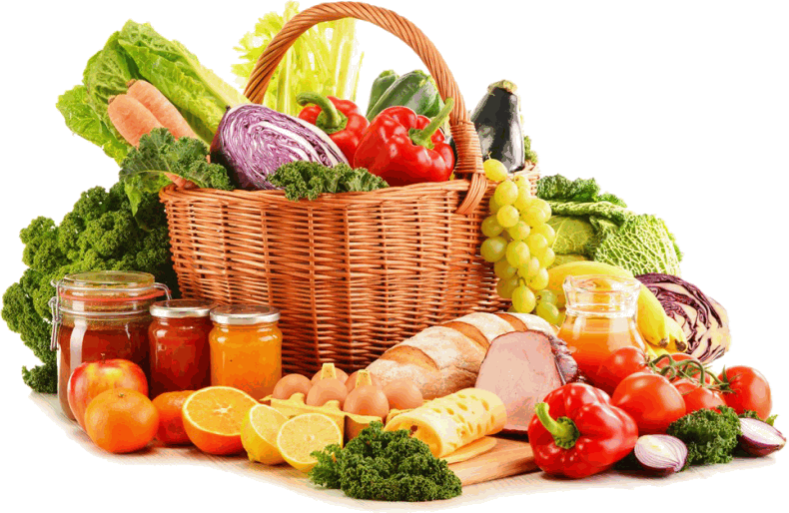

Jo:
07895540494


PLEASE NOTE THERE WILL BE PRODUCE IN THE SHOW THAT WILL CONTAIN NUTS
RULES FOR EXHIBITORS

Exhibitors must reside in the parish of Brading, Alverstone or Yaverland.
ALL exhibits must be home grown produce with the exception of flowers for the Floral and Art sections - Classes 69 - 73.

All of Section 4 exhibits must display a list of ingredients.
No exhibitor may stage more than one exhibit in each class.
The Committee reserve the right to make more or fewer awards as the Judge may think fit.
Wine must be openable!
Stewards and committee members only are allowed in the hall when judging is taking place.
Exhibits NOT according to schedule will be disqualified.

CLASS ENTRANCE FEE; 30p per entry must accompany the entrance form.
PLEASE READ CAREFULLY
Exhibits may be staged from 8pm to 9pm on Friday evening and 7.30 am to 10.30am on the morning of the show.
No exhibit may be removed before 4.30pm without permission of the Secretary.
All exhibits must be cleared by 5 pm on the evening of the show.
In the collection of vegetables, the number of vegetables of each variety must be 5 of each.
No appeal against the Judge’s awards will be entertained unless a deposit of £1 be accompanied by a written protest before 3.30 pm on day of Show. If such protest is sustained the deposit will be returned.

The Committee reserves the right to inspect gardens after the receipt of entries.
POINTS AWARDED IN CLASSES: 1st = 3 2nd = 2 3rd = 1

very important.

HINTS FOR EXHIBITORS
Study the schedule carefully, it gives details of the classes, rules and conditions.
Fill in your entry form accurately as the class number is


Deliver it to either address on the schedule cover BEFORE 8pm on the Wednesday before the show. They may be given in before this day (it will help us with organising).

ALLOW yourself enough time on the morning of the show.

When delivering your exhibits, get your exhibitors number from the show secretary. There will be a card bearing your number for every class which you have entered. This card is placed face-down on the table under your entry. Class numbers will be at the front of the bench where you should place your entry in accordance with the schedule.
If in doubt, PLEASE ask a steward who will be pleased to help.
Vases are supplied for Section 1 classes and plates are provided for vegetables and fruit.
For the Top Vase Class, please read rules on page 10. Check that you have staged the correct number of specimens in the appropriate class.
Vegetables: Wash and clean root vegetables with a soft sponge, never use a brush. Do not use oil or grease. Beetroots, carrots and turnips should have leaves shortened to NOT LESS than 7.5cms (3”).
Onions should be shown without tops and must not be skinned.
Runner beans should have flower stalks attached.
Tomatoes should be uniform in size, firm, with a green stalk intact on each.

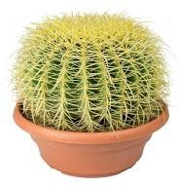

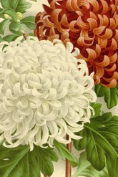
CLASSES
Section 1. FLOWERS Prizes: 1st=50p 2nd=40p 3rd=30p
- 1 Vase Alstroemeria. 3 stems in a vase.
- 1 Vase Outdoor Spray Chrysanthemums. 3 stems in vase.
- 1 Vase Decorative Dahlias. Any variety 3 blooms in vase. (please note that Dahlias not judged under N.D.S rules).
- 1 Vase Michaelmas Daisies. 3 stems in vase.
- 1 Vase Specimen Rose. 1 stem in vase (open not bud).
- 1 Vase any flower with own foliage. 3 stems in vase.
- Largest Sunflower Head. Allow 12.5cms (5”) of stem.
- 1 Vase My Special Bloom (not rose).
- TOP VASE: a vase of mixed flowers and foliage (all round effect, no accessories).

Please make sure your vases of flowers have sufficient water.
- Flowering Pot Plant (pot not exceeding 30cms).
- Foliage Pot Plant (pot not exceeding 30cms).
- Cactus (pot not exceeding 30cms).
- Succulent (pot not exceeding 30cms).

Section 2. FRUIT
- 3 Cooking Apples
- 3 Dessert Apples
- Dish of Soft Fruit: 10 Blackberries with stalks. 3 Plums/Greengages, 6 Raspberries
- Heaviest Single Apple

Any queries? Please ask one of the stewards.

Section 3. VEGETABLES Prizes: 1st=50p 2nd=40p 3rd=30p
- 3 White Potatoes
- 3 Coloured Potatoes


- 3 Beetroot. Globe.
- 6 Tomatoes. Any variety except Cherry.
- 6 Small Fruited Tomatoes. No larger than 35mm.
- 5 Onions. Exhibit on own staging.
- Wonky Vegetable (Any)
- 5 Shallots
- 3 Carrots. Short.
- 3 Carrots. Long or intermediate.
- 1 Squash
- 3 Peppers. Any colour.
- 5 Chillies. Any colour.

MASTER GARDENER
A collection of 2 items from the following:
  - Dish of vegetables. 5 varieties.
  - Dish of fruit. 5 varieties.
  - Vase of flowers. 3 stems.
  - Pot plant. Maximum size of pot (6”)
- 6 Runner Beans
- Runner Bean. Longest.
- 6 French Beans
- Pumpkin
- Marrow/Courgette. Heaviest .
- 3 Chicken Eggs
- The Nunwell Challenge Cup Prizes: 1st=£3 2nd=£2 3rd= £1 Sponsored class with special prizes.
A collection of 4 distinct vegetable varieties displayed in own dish.
- The Brading Collection Prizes: 1st=£3 2nd=£2 3rd= £1
Sponsored class with special Prizes.
A collection of fruit and vegetables from your garden or allotment presented in a basket/trug. Judged for presentation only.

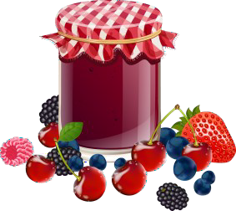

Section 4. HOME PRODUCE Prizes: 1st=50p 2nd=40p 3rd=30p

Please note: All home produce to use own recipe unless stated.
- White Loaf . 1lb tin.
- Jar of Jam.
- Jar of Marmalade.
- Jar of Curd.
- Jar of Chutney
- Jar of Pickled Onions. Screw top.
- Jar of any pickled vegetable.
- Apple Pie
- Gingerbread. 4 square pieces.
- 1 Meat pasty .

Please note: NO commercial or fabric tops on preserves.

- MEN ONLY Bread Pudding. 4 squares. Ingredients:
500g White Bread 500g mixed fruit 1 tbs mixed spice 600ml milk
2 large eggs beaten 140g brown sugar 100g butter
2tbs demerara sugar
Method:
Tear the bread into a large mixing bowl, add the fruit & spice. Pour in the milk then scrunch through your fingers to mix everything together and
break up bread. Add eggs & demerara sugar, stir well and leave to soak for 15 minutes.
Heat oven to 180c/160c fan. Butter & line a 20cm square cake tin. Stir the butter into the mixture, tip into tin, scatter demerara sugar on top. Bake in oven for 1½ hours until firm & golden.




Section 5. CRAFTS Prizes: 1st=50p 2nd=40p 3rd=30p
- Decorated Christmas Card with envelope. Any medium.
- Knitted Item. Any ply.
- Crochet Item
- Something New from Something Old
- Any Other Craft (hard) including jewellery, wood etc.
- Any Needlecraft e.g. Cross Stitch, Tapestry, Long-stitch Embroidery.
- Art. Button Picture in frame not to exceed 8” x 6”
- Project from Paper/Fabric not to exceed 8” x 6” Section 6. PHOTOGRAPHY (The Aylmer Salver) Photos to be titled and mounted
- Miscellaneous
- The Isle of Wight Scene
- Sunset
Section 7. JUNIOR SECTION Prizes: 1st=50p 2nd=40p 3rd=30p
- 4 Decorated “Face” Rich Tea biscuits. 4-6 years.
- 4 Decorated fairy cakes. Baked and decorated.
- Craft Work (any) 4 to 7 years.
- Craft Work (any) 8 to 16 years.
- Photograph anywhere on Island. 8 to 16 years.
- Necklace or Bangle. Handmade. 6-11 years.
- BRADING HORTICULTURAL SOCIETY HOME GROWN PRODUCE SHIELD.
Junior Produce. 3 homegrown items, shown on a plate. Aged up to 16 years.

Classes for Brading Primary School are arranged by the school and are done as part of the Curriculum.
Section 8. FLORAL ART Prizes: 1st=50p 2nd=40p 3rd=30p Flowers may be purchased for these classes.
- Autumn Door Wreath. Artificial materials allowed.
- Space Theme. Using fresh plant materials, accessories and foliage . Size not larger than 50cms (20”).
- Ladies Button Hole.


FLOWER ARRANGING NOTES:
Accessory: Anything other than plant material used as part of the exhibit, EXCEPT bases, containers and drapes.
Drapes: Fabric or material placed behind or in association with an exhibit. Drapes are not considered to be accessories.
Dried: Any dried, preserved, bleached or skeletonised plant material including driftwood.
Exhibit: Plant material with or without accessories.
Natural Plant Material: Fresh and/or dried plant material.
Alcove: Recess in which an exhibit is staged.

TIPS FROM JUDGES:
Make sure the exhibit is according to schedule. Plant materials predominate.
The exhibit interprets the class title. The space allowed is well used.
Don’t over-accessorise. Keep the accessories in scale with each other. Keep it simple.
Make sure your arrangement has sufficient water.

SHOW TIPS
Two or three weeks before the show keep your soil moist with plenty of water. Protect your special blooms from heavy rain or splashing.
Cut flowers and foliage early morning or late evening when it is cool.
Cut stems as long as possible with a slanting cut to assist uptake of water.

Put into water as soon as possible!
Give pot plants a generous watering. Remove any damaged flowers and broken and discolored leaves.

DO NOT EXHIBIT DAMAGED OR DISEASED FRUIT AND VEGETABLES

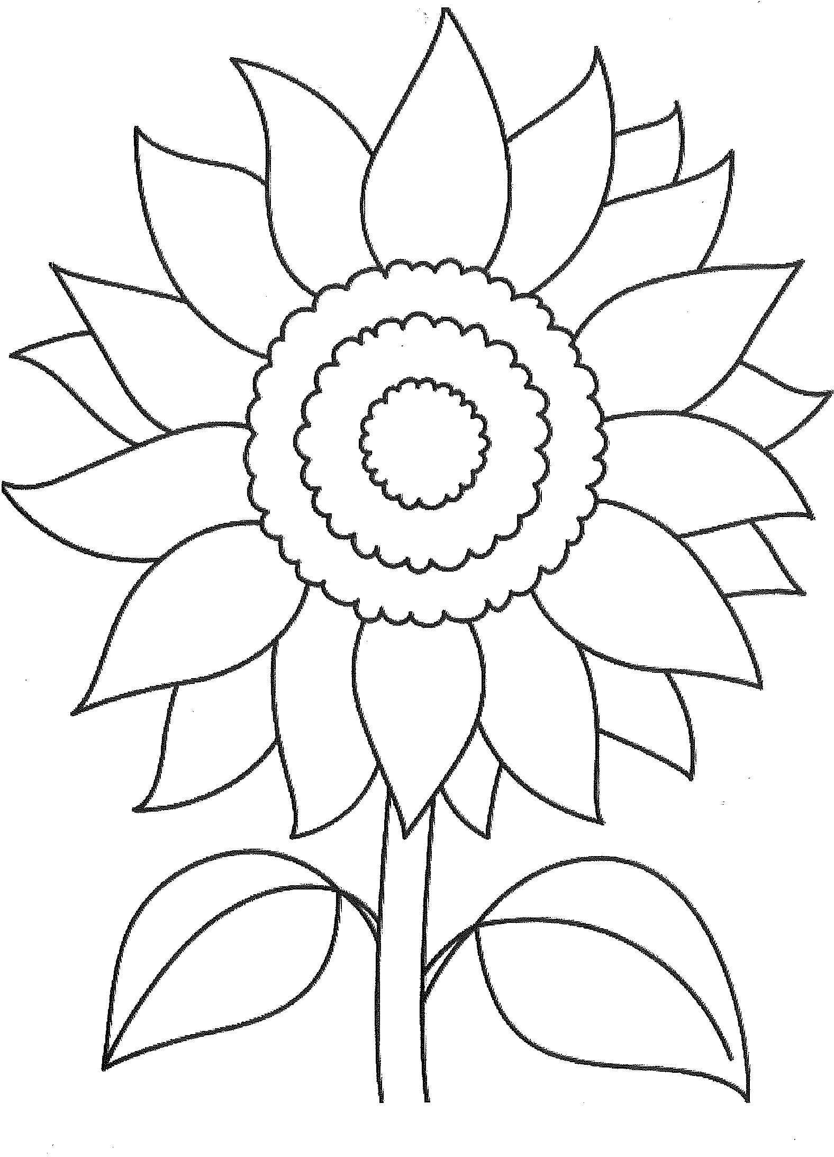
Class 72 (Children up to 9 years old)

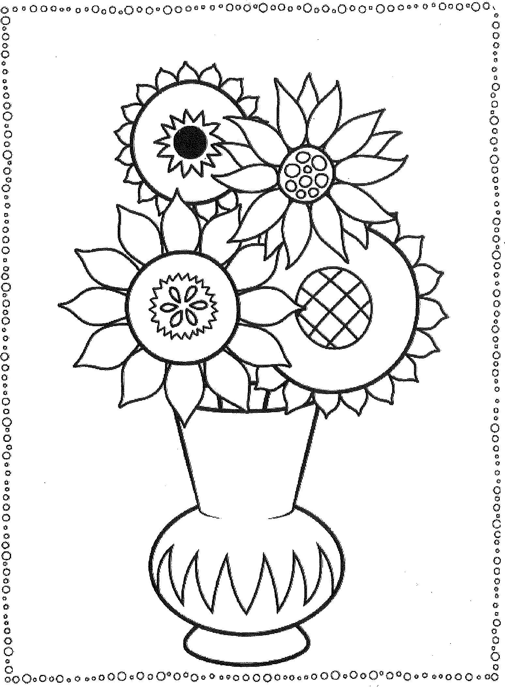
Class 73 (Children 10 to 16 years old)



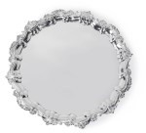
TROPHIES AND PRIZES

H. WEEKS CHALLENGE CUP For most points in Section 3,
Vegetables.
MISS WOODS CHALLENGE CUP For most points in Section 4,
Home-made Produce
LITTLE JANE’S CHALLENGE CUP For most points in Section 8,
Floral Art
CAPT. DRAYSON CHALLENGE CUP For most points in Section 1, Classes 1
and 2, Flowers
M. HARRIS CHALLENGE CUP For most points in Section 1, Classes 3, 4, 5, 6, 7 & 8, Flowers
STOREY CHALLENGE CUP For most points in Section 5, Crafts
ROSE SOCIETY CUP For most points in Section 2, Fruit Junior Section
W. HARRIS CHALLENGE CUP Most points in Classes, 77 & 79
BHS JUNIOR HOME GROWN PRODUCE SHIELD Junior Produce up to age 16, Class 78
BO-PEEP CUP Coloring in competition
NUNWELL CHALLENGE CUP Winner of Class 42, Vegetables
W. E. HARBOUR MEMORIAL CUP Most points in Classes 25, 26, 27 & 28,
Vegetables
VERA GUSTAFSON MEMORIAL BOWL For the lady with most points in the
show.
I.O.W HORTICULTURAL SOCIETY Certificates awarded to the Best Exhibits in show.
THE MORGAN TROPHY For best exhibit in show Judges
choice
GORDON TROTT SHIELD Winner of Class 30, Vegetables
THE AYLMER SALVER For most points in Section 6,
Photography
COX MEMORIAL SHIELD For most points in Classes 10, 11, 12 & 13, Flowers



COMMITTEE MEMBERS

CHAIR PERSON Jo Horn
SECRETARY Steph Hodge
TREASURER Linda Allen Jeanette Edmunds
Viv Langford Irene Brawn Christine Chambers

Please can all cups be returned, in a clean and presentable condition, to The New Town Hall, Brading. Thank you.

Grateful thanks go to
Brading Town Council for producing the Show Schedule and local businesses in taking part

The Committee would like to thank everyone who generously gives their time to help with the Show.

Information correct at time of going to print

BRADING HORTICULTURAL SHOW
CERTIFICATE OF ENTRY
Name: ……………………………………………………………………………………………
Address: ………………………………………………………………………………………..
…………………………………………………………………………………………..
Telephone Number: ………………………………………………………………………
PLEASE CIRCLE CLASSES ENTERED

1 | 2 | 3 | 4 | 5 | 6 | 7 | 8 | 9
10 | 11 | 12 | 13 | 14 | 15 | 16 | 17 | 18
19 | 20 | 21 | 22 | 23 | 24 | 25 | 26 | 27
28 | 29 | 30 | 31 | 32 | 33 | 34 | 35 | 36
37 | 38 | 39 | 40 | 41 | 42 | 43 | 44 | 45
46 | 47 | 48 | 49 | 50 | 51 | 52 | 53 | 54
55 | 56 | 57 | 58 | 59 | 60 | 61 | 62 | 63
64 | 65 | 66 | 67 | 68 | 69 | 70 | 71 | 72
73

ENTRIES BY FRIDAY 4TH SEPTEMBER
Number of entries ……. @ 30p Entry fee due: ……….

I CERTIFY THE ABOVE ENTRIES WERE GROWN OR MADE BY MYSELF
Signed: …………………………………………………………………………….

BRADING HORTICULTURAL SHOW
CERTIFICATE OF ENTRY
Name: ……………………………………………………………………………………………
Address: ………………………………………………………………………………………..
…………………………………………………………………………………………..
Telephone Number: ………………………………………………………………………
PLEASE CIRCLE CLASSES ENTERED

1 | 2 | 3 | 4 | 5 | 6 | 7 | 8 | 9
10 | 11 | 12 | 13 | 14 | 15 | 16 | 17 | 18
19 | 20 | 21 | 22 | 23 | 24 | 25 | 26 | 27
28 | 29 | 30 | 31 | 32 | 33 | 34 | 35 | 36
37 | 38 | 39 | 40 | 41 | 42 | 43 | 44 | 45
46 | 47 | 48 | 49 | 50 | 51 | 52 | 53 | 54
55 | 56 | 57 | 58 | 59 | 60 | 61 | 62 | 63
64 | 65 | 66 | 67 | 68 | 69 | 70 | 71 | 72
73

ENTRIES BY FRIDAY 4TH SEPTEMBER
Number of entries ……. @ 30p Entry fee due: ……….

I CERTIFY THE ABOVE ENTRIES WERE GROWN OR MADE BY MYSELF
Signed: …………………………………………………………………………….

BRADING HORTICULTURAL SHOW
CERTIFICATE OF ENTRY
Name: ……………………………………………………………………………………………
Address: ………………………………………………………………………………………..
…………………………………………………………………………………………..
Telephone Number: ………………………………………………………………………
PLEASE CIRCLE CLASSES ENTERED

1 | 2 | 3 | 4 | 5 | 6 | 7 | 8 | 9
10 | 11 | 12 | 13 | 14 | 15 | 16 | 17 | 18
19 | 20 | 21 | 22 | 23 | 24 | 25 | 26 | 27
28 | 29 | 30 | 31 | 32 | 33 | 34 | 35 | 36
37 | 38 | 39 | 40 | 41 | 42 | 43 | 44 | 45
46 | 47 | 48 | 49 | 50 | 51 | 52 | 53 | 54
55 | 56 | 57 | 58 | 59 | 60 | 61 | 62 | 63
64 | 65 | 66 | 67 | 68 | 69 | 70 | 71 | 72
73

ENTRIES BY FRIDAY 4TH SEPTEMBER
Number of entries ……. @ 30p Entry fee due: ……….

I CERTIFY THE ABOVE ENTRIES WERE GROWN OR MADE BY MYSELF
Signed: …………………………………………………………………………….

BRADING HORTICULTURAL SHOW
CERTIFICATE OF ENTRY
Name: ……………………………………………………………………………………………
Address: ………………………………………………………………………………………..
…………………………………………………………………………………………..
Telephone Number: ………………………………………………………………………
PLEASE CIRCLE CLASSES ENTERED

1 | 2 | 3 | 4 | 5 | 6 | 7 | 8 | 9
10 | 11 | 12 | 13 | 14 | 15 | 16 | 17 | 18
19 | 20 | 21 | 22 | 23 | 24 | 25 | 26 | 27
28 | 29 | 30 | 31 | 32 | 33 | 34 | 35 | 36
37 | 38 | 39 | 40 | 41 | 42 | 43 | 44 | 45
46 | 47 | 48 | 49 | 50 | 51 | 52 | 53 | 54
55 | 56 | 57 | 58 | 59 | 60 | 61 | 62 | 63
64 | 65 | 66 | 67 | 68 | 69 | 70 | 71 | 72
73

ENTRIES BY FRIDAY 4TH SEPTEMBER
Number of entries ……. @ 30p Entry fee due: ……….

I CERTIFY THE ABOVE ENTRIES WERE GROWN OR MADE BY MYSELF
Signed: …………………………………………………………………………….

